1. 题目

18160: 最大连通域面积

dfs similar, http://cs101.openjudge.cn/practice/18160

代码：

def dfs(matrix, row, col, visited):

if row < 0 or row >= len(matrix) or col < 0 or col >= len(matrix[0]) \

or matrix[row][col] != 'W' or visited[row][col]:

return 0

visited[row][col] = True

size = 1

for dr in [-1, 0, 1]:

for dc in [-1, 0, 1]:

size += dfs(matrix, row + dr, col + dc, visited)

return size

def max_connected_area(matrix):

max_area = 0

visited = [[False for _ in range(len(matrix[0]))] for _ in range(len(matrix))]

for row in range(len(matrix)):

for col in range(len(matrix[0])):

if matrix[row][col] == 'W' and not visited[row][col]:

area = dfs(matrix, row, col, visited)

max_area = max(max_area, area)

return max_area

def main():

T = int(input())

for _ in range(T):

N, M = map(int, input().split())

matrix = [input().strip() for _ in range(N)]

print(max_connected_area(matrix))

if __name__ == "__main__":

main()

代码运行截图 （至少包含有"Accepted"）

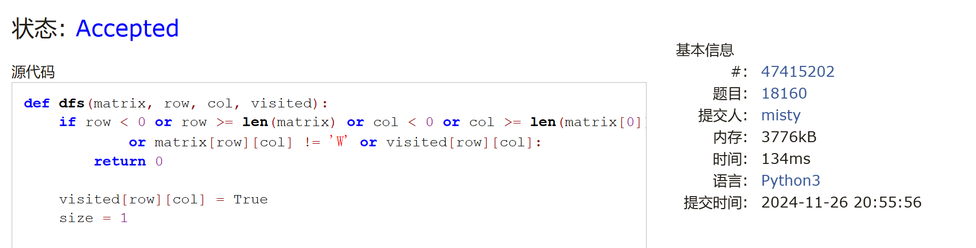

19930: 寻宝

bfs, http://cs101.openjudge.cn/practice/19930

代码：

import heapqdef bfs(x,y):

d=[[-1,0],[1,0],[0,1],[0,-1]]

queue=[]

heapq.heappush(queue,[0,x,y])

check=set()

check.add((x,y))

while queue:

step,x,y=map(int,heapq.heappop(queue))

if martix[x][y]==1:

return step

for i in range(4):

dx,dy=x+d[i][0],y+d[i][1]

if martix[dx][dy]!=2 and (dx,dy) not in check:

heapq.heappush(queue,[step+1,dx,dy])

check.add((dx,dy))

return "NO"

m,n=map(int,input().split())martix=[[2]*(n+2)]+[[2]+list(map(int,input().split()))+[2] for i in range(m)]+[[2]*(n+2)]print(bfs(1,1))

代码运行截图 ==（至少包含有"Accepted"）==

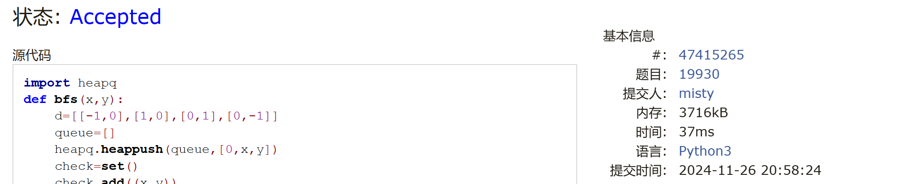

04123: 马走日

dfs, http://cs101.openjudge.cn/practice/04123

代码：

T = int(input())

for i in range(T):

list1 = list(map(int, input().split()))

n = list1[0]

m = list1[1]

x = list1[2]

y = list1[3]

direct = [(-1, -2), (-1, 2), (1, -2), (1, 2), (2, 1), (2, -1), (-2, 1), (-2, -1)]

def dfs(x, y, lst, t):

s = 0

if t == n * m:

return 1

else:

for v, w in direct:

if (x + v, y + w) not in lst and x + v in range(n) and y + w in range(m):

lst.append((x + v, y + w))

s += dfs(x + v, y + w, lst, t + 1)

lst.pop()

return s

lst = [(x, y)]

print(dfs(x, y, lst, 1))

代码运行截图 （至少包含有"Accepted"）

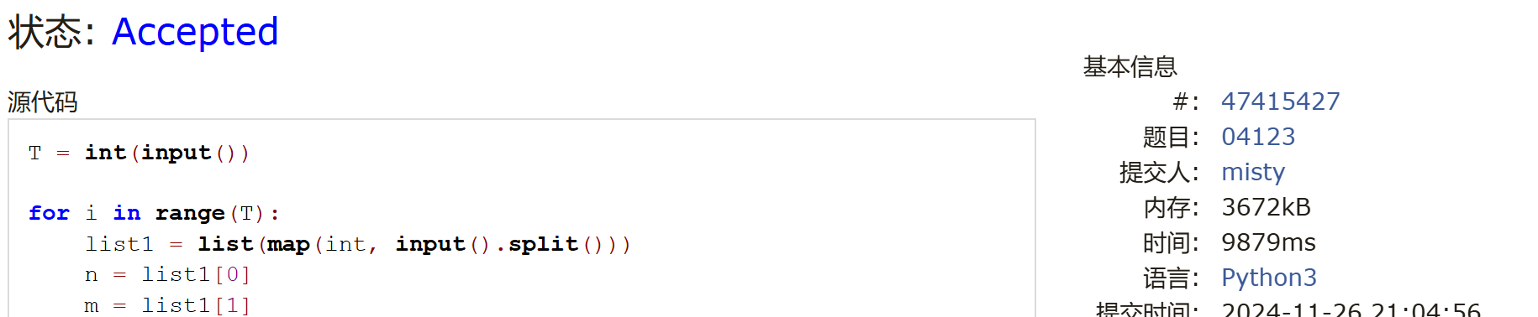

sy316: 矩阵最大权值路径

dfs, https://sunnywhy.com/sfbj/8/1/316

代码：

def dfs(x, y, now_value):  
 global max_value, opt_path  
 if x == n - 1 and y == m - 1:  
 if now_value > max_value:  
 max_value = now_value  
 opt_path = temp_path[:]  
 return  
  
 visited[x][y] = True  
  
 for dx, dy in directions:  
 next_x, next_y = x + dx, y + dy  
 if 0 <= next_x < n and 0 <= next_y < m and not visited[next_x][next_y]:  
 next_value = now_value + maze[next_x][next_y]  
 temp_path.append((next_x, next_y))  
 dfs(next_x, next_y, next_value)  
 temp_path.pop()   
  
 visited[x][y] = False  
  
  
n, m = map(int, input().split())  
maze = [list(map(int, input().split())) for _ in range(n)]  
  
max_value = float('-inf')  
opt_path = []  
temp_path = [(0, 0)]  
visited = [[False] * m for _ in range(n)]  
directions = [(0, 1), (0, -1), (1, 0), (-1, 0)]  
  
dfs(0, 0, maze[0][0])  
  
for x, y in opt_path:  
 print(x + 1, y + 1)

代码运行截图 （至少包含有"Accepted"）

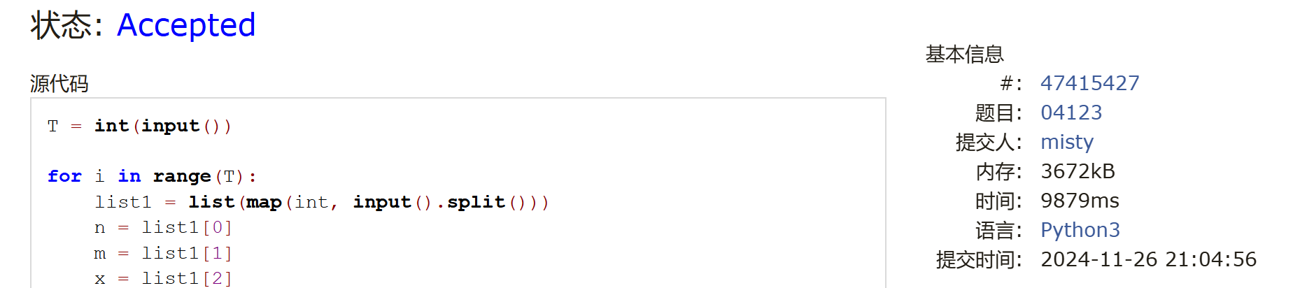

LeetCode62.不同路径

dp, https://leetcode.cn/problems/unique-paths/

代码：

class Solution:

    def uniquePaths(self, m: int, n: int) -> int:

        f = [1] * n

        for i in range(1, m):

            for j in range(1, n):

                f[j] += f[j - 1]

        return f[n - 1]

代码运行截图 （至少包含有"Accepted"）



sy358: 受到祝福的平方

dfs, dp, https://sunnywhy.com/sfbj/8/3/539

代码：

def is_blessed_id(A):  
 squares = set()  
 i = 1  
 while i * i <= 10 ** 9:  
 squares.add(i * i)  
 i += 1  
  
 digits = list(map(int, str(A)))  
  
 def dfs(idx):  
 if idx == len(digits):  
 return True  
  
 num = 0  
 for i in range(idx, len(digits)):  
 num = num * 10 + digits[i]  
 if num in squares:  
 if dfs(i + 1):  
 return True  
 return False  
  
 return "Yes" if dfs(0) else "No"  
  
  
A = int(input())  
print(is_blessed_id(A))

代码运行截图 （至少包含有"Accepted"）

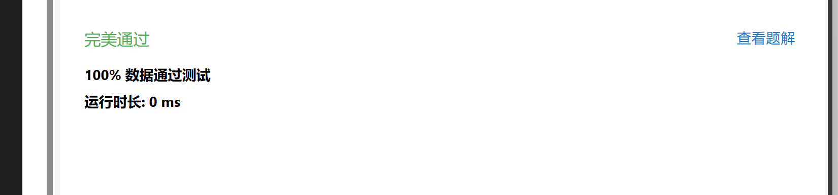

2. 学习总结和收获

1.最近的讲义还没有过完，掌握的不好

2.dp比之前会做了，感觉更容易有做题的思路

3.练习题list在慢慢赶进度